Project Design Phase
Problem – Solution Fit Template

Date | 25 June 2025
Team ID | LTVIP2025TMID59612
Project Name | SB Foods - On-Demand Food Ordering Platform
Maximum Marks | 2 Marks

Problem – Solution Fit Template:
The Problem-Solution Fit simply means that you have found a problem with your customer and that the solution you have realized for it actually solves the customer’s problem. It helps entrepreneurs, marketers and corporate innovators identify behavioral patterns and recognize what would work and why
Purpose:
- Solve real-world food ordering challenges faced by customers, restaurants, and administrators.
- Accelerate solution adoption by integrating into users’ existing habits and behaviors (e.g., mobile usage, contactless delivery).
- Improve communication through clear, focused messaging that resonates with user needs.
- Build trust by solving recurring issues and streamlining the ordering experience.
- Analyze and improve the current food ordering ecosystem by identifying gaps.

Template:
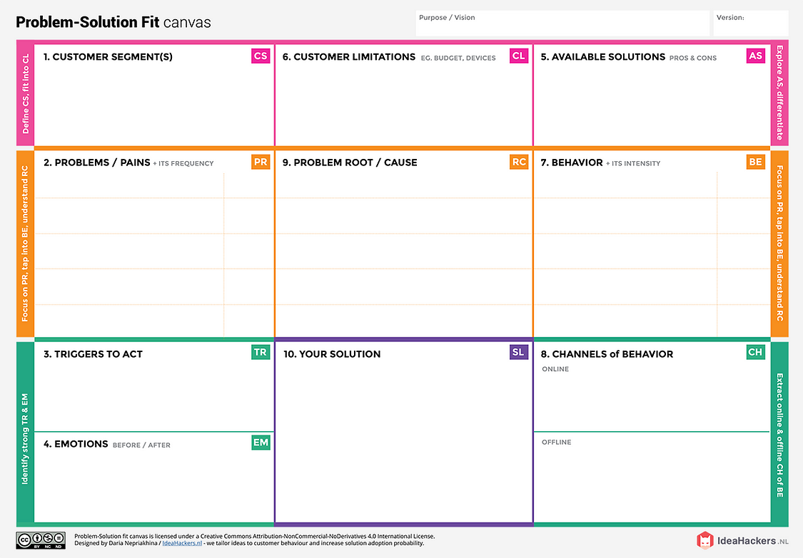
SB Foods app with dedicated “Late Night Cravings” section
Only displays open restaurants for current time and location
Instant ordering, saved profiles, & secure payments
Feedback-driven AI suggestions and simplified UX for night use
Lack of 24/7 food access
Mainstream food apps not optimized for late-night users
Limited awareness of available open vendors
No specialized interface for midnight cravings
Word-of-mouth in hostels, campus boards
Rarely visits stores late night due to safety concerns
Mobile apps (primary), social media, food forums
High urgency during late-night hunger
Frequent use of food apps
Impulsive behavior in food selectionRelies on reviews or past orders
Limited student budget
Dependent on mobile phones (Android/iOS)
Prefers apps with wallet/UPI options
Internet availability in hostels may be poor sometimes
Zomato/Swiggy: Popular, but coverage varies & late-night options are limited
Instant noodles/snacks: Quick but unhealthy
Canteens/local eateries: Usually closed late night
Calling restaurants directly: No real-time menu, no guarantee
Before: Hungry, tired, frustrated, anxious
After: Satisfied, relieved, focused, cared-for
Physical hunger or skipped meals
Peer recommendations
Pop-up notifications offering late-night discounts
Exam stress or long work hours
Hunger during late hours
Limited/no food options after 11 PM
Unreliable delivery services
Time wasted browsing for open vendors
Security concerns going out at night
College students (18–25 yrs), night owls
Working professionals with irregular hours
Hostel/PG residents
Single urban dwellers relying on food delivery
Summary:
SB Foods solves a common, frequent, and costly problem in a simple and clear manner:
- For users: No more app clutter or guessing what’s available.
- For restaurants: Independence and visibility.
- For admins: Simplified moderation and system health.
The solution is crafted to match existing user behavior (mobile-first, fast decisions), and taps into pain points faced in conventional apps. This ensures higher adoption, repeat usage, and stakeholder satisfaction.

References:
- https://www.ideahackers.network/problem-solution-fit-canvas/
- https://medium.com/@epicantus/problem-solution-fit-canvas-aa3dd59cb4fe

